### Mirrors-Chinese -Camann-1955

### [Archives of the Chinese Art Society of America - Issues 9-12 - Page 51](http://books.google.com/books?id=z8EMAQAAIAAJ&q="grapes+as+symbols+of+abundance"&dq="grapes+as+symbols+of+abundance"&hl=en&sa=X&ei=FK-rULLWL6fO0QH19YCABA&ved=0CDMQ6AEwAQ)

[Chinese Art Society of America](https://www.google.com/search?hl=en&safe=off&tbo=d&tbm=bks&tbm=bks&q=inauthor:"Chinese+Art+Society+of+America") - 1955 -

# Significant Patterns on Chinese Bronze Mirrors

Submitted by [James Miller](http://www.daoiststudies.org/dao/users/james-miller) on Mon, 05/25/2009 - 12:55



|  |  |
| --- | --- |
| Title | Significant Patterns on Chinese Bronze Mirrors |
| Publication Type | Journal Article |
| Year of Publication | 1955 |
| Authors | [Cammann, Schuyler](http://www.daoiststudies.org/dao/biblio/author/1991) |
| Journal | Archives of the Chinese Art Society of America |
| Volume | 9 |
| Date Published | Jan |
| URL | <http://www.jstor.org/stable/20066972> |

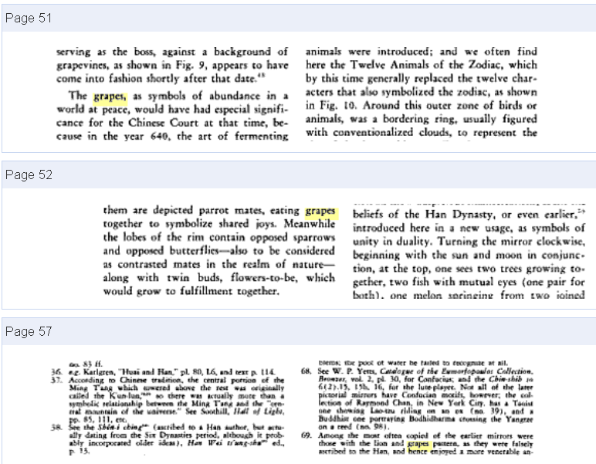

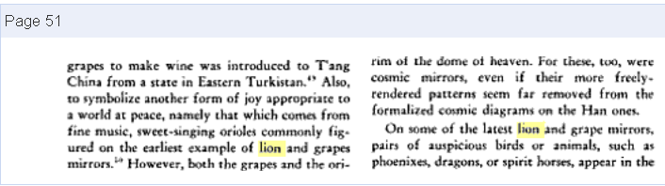 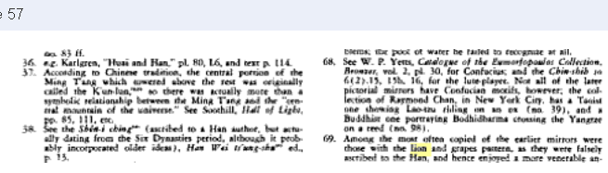 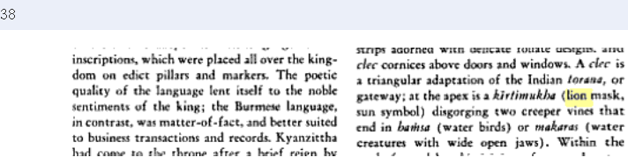

52

